Project Design Phase-II Data Flow Diagram User Stories

|  |  |
| --- | --- |
| Date | 19 October 2022 |
| Team ID | PNT2022TMID23663 |
| Project Name | Signs with Smart Connectivity for Better Road  Safety |
| Maximum Marks | 4 Marks |

**Data Flow Diagram:**

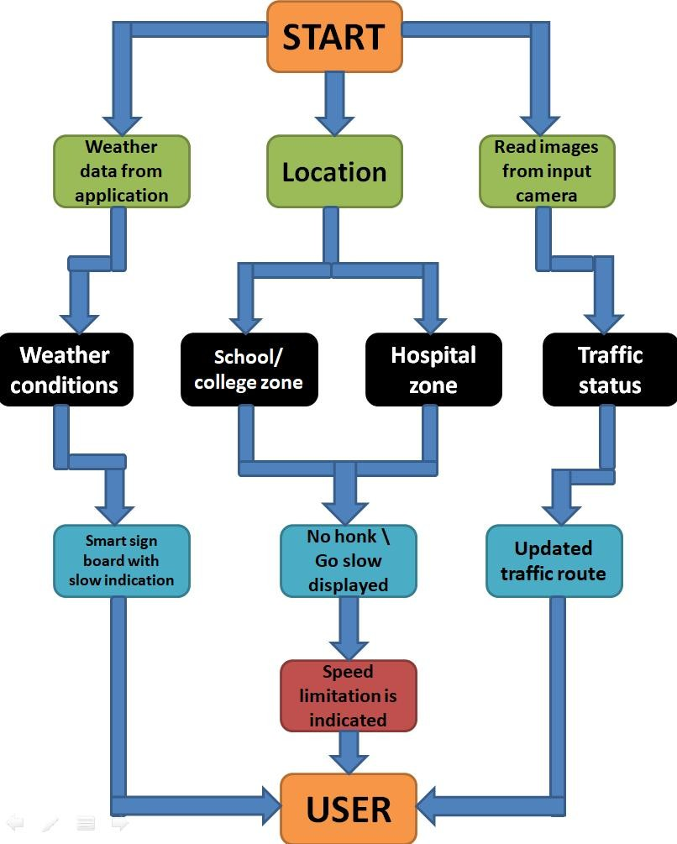

**User Stories**

|  |  |  |  |  |  |  |
| --- | --- | --- | --- | --- | --- | --- |
| **User Type** | **Funct ional Requi remen**  **t (Epic)** | **User Story Numb er** | **User Story / Task** | **Acceptance criteria** | **Priority** | **Release** |
| Customer (Mobile user) | Registration | USN-1 | I can get my speed limitation using  weather application. | I can receive  speed limitations | High | Sprint-1 |
|  |  | USN-2 | As a user, I can register for the application byentering my email, password, and confirmingmy password.  As a user, | I can access my account  /dashboar d | Medium | Sprint-2 |
|  |  | USN-3 | As a user, I can increase or decrease myspeed according to the weather change | I can increase or decrease  my speed | High | Sprint-1 |
|  |  | USN-4 | As a user, I can I get my traffic diversion signs  depending on the traffic and the fatalsituations. | I can access my traffic status  ahead in my travel | Medium | Sprint-1 |
|  | Login | USN-5 | As a user, I can log into the open weathermap byentering email & password | I can access the application  through my Gmail login | High | Sprint-2 |
|  | Interface | USN-6 | As a user the interface should be simple andeasily accessible | I can access the interfaceeasily | High | Sprint-1 |
| Customer (Web user) | Data generation | USN-7 | As a user I use open weather application to access the data regarding the weather changes. | I can access the data regarding the weather  through the application | High | Sprint-1 |
| Admini strator (Officia ls) | Problem solving/ Fault clearance | USN-8 | As an official who is in charge for the proper functioning of the sign boards have to maintain it through periodic monitoring. | Officials can monitor thesign boards for proper  functioning. | Medium | Sprint-2 |